 | MASTER WORK ORDER  Alder Residence — Portland, OR

Customer | Casey Alder
Address | 1234 SE Alder St, Portland, OR 97215
Phone | (503) 555-0136
Questions on site | Kyle — (503) 555-0117
Job # | 2026-0714
Install Dates | Aug 4–5, QC day Aug 6
Crew Lead | ___________________________
⚠ SAFETY FLAGS: LEAD PAINT — 1962 home, lead-safe (RRP) practices on any paint disturbance
Site Access & Homeowner Notes
• Access: front door, lockbox on hose bib — code with homeowner; park in driveway, keep the sidewalk clear
• Occupants: Casey works from home (back office); indoor cat — keep exterior doors closed
The House
• 1962 one-story bungalow, 940 sf, vented attic, crawlspace foundation
• Existing heat: gas furnace (hall closet, ducts through the attic) — coming out Day 1
• Gas stays live at the meter for the range and water heater — cap at the furnace only
Homeowner Concerns (from walkthrough)
• Comfort first: living room runs cold every winter, bedroom overheats in summer
• Kitchen has no exhaust at all — new hood is a big deal to Casey
• Kitchen remodel is NOT in this scope (homeowner aware) — hood vents through the existing cabinet run
Trades Summary
Trade | In this job
HVAC | Remove gas furnace · Install ductless heat pump · Range hood duct · Bath fan
WEATHERIZATION | Attic air seal · Attic prep + insulation
ELECTRICAL | New 240V circuit for heat pump
Schedule
Day | Crews | Work
Day 1 (Mon) — Furnace out + attic open + air-seal start | HVAC · WX · ELEC | HVAC: furnace out, gas capped at the appliance, attic ducts out · WX: vacuum attic clean, start air seal, hold hood/fan duct spots · ELEC: run + energize ODU circuit
Day 2 (Tue) — Heat pump + ducts + seal + blow | HVAC · WX | HVAC: set ODU + heads + linesets, run hood + bath-fan ducts, commission both zones · WX: seal around new ducts, finish air seal, attic prep · blower door verifies tight · WX: blow R-49
QC Day (Wed) — Test + walkthrough + sign-off | Lead + assessor | Final blower door · walk every measure · homeowner sign-off
• The attic opens Day 1 so every duct runs Day 2 before anything is sealed or blown.
• Both install crews on site Days 1–2; the whole install finishes Day 2.
• Blow R-49 LAST — only after the blower door verifies the air barrier tight.
• QC day is non-production: final numbers, walkthrough, sign-off.
Book these dates:
Day 1 (Mon) — Furnace out + attic open + air-seal start: _______________________
Day 2 (Tue) — Heat pump + ducts + seal + blow: _______________________
QC Day (Wed) — Test + walkthrough + sign-off: _______________________
Scope of Work
Trade | Task | Details | Location
HVAC | Remove gas furnace | Cap gas at the appliance, remove furnace + attic duct runs, haul away | Hall closet + attic
HVAC | Install ductless heat pump | 24k cold-climate outdoor unit on east wall pad, 12k wall head (living), 9k wall head (bedroom), linesets through attic | East wall, living room, bedroom
HVAC | Range hood duct | Duct new 300 CFM hood through upper cabinet, out the wall cap with damper | Kitchen
HVAC | Bath fan | ENERGY STAR 110 CFM fan with humidistat, duct out the roof, first 3 ft straight | Hall bath
WEATHERIZATION | Attic air seal | Full ceiling plane: top plates, can lights, penetrations, flue dam; hold the hood + bath-fan duct spots Day 1 and close them after HVAC runs ducts Day 2 | Attic
WEATHERIZATION | Attic prep + insulation | Baffles at every eave bay, hatch dam + weatherstrip, 3 depth markers, then blow R-49 cellulose over 940 sf | Attic
ELECTRICAL | New 240V circuit for heat pump | 25A 2-pole breaker, 10/2 from panel to east-wall disconnect, whip to ODU | Panel (garage) to east wall
Equipment Arriving
Item | Model | Qty
Outdoor unit | 24k cold-climate ductless ODU | 1
Wall heads | 12k (living) + 9k (bedroom) | 2
Bath fan | 110 CFM ENERGY STAR, humidistat | 1
Range hood | 300 CFM ducted | 1
Disconnect + whip | 60A non-fused | 1
DAY 1 (MON) — FURNACE OUT + ATTIC OPEN + AIR-SEAL START — HVAC · WX · ELEC
☐ HVAC — furnace out, gas capped at the appliance, attic ducts out
☐ WX — vacuum attic clean, start air seal, hold hood/fan duct spots
☐ ELEC — run + energize ODU circuit
☐ DAY 1 (MON) — FURNACE OUT + ATTIC OPEN + AIR-SEAL START DONE — site clean and safe, next phase ready
☐ Photos of today's work sent to the office
DAY 2 (TUE) — HEAT PUMP + DUCTS + SEAL + BLOW — HVAC · WX
☐ HVAC — set ODU + heads + linesets, run hood + bath-fan ducts, commission both zones
☐ WX — seal around new ducts, finish air seal, attic prep
☐ blower door verifies tight
☐ WX — blow R-49
☐ DAY 2 (TUE) — HEAT PUMP + DUCTS + SEAL + BLOW DONE — site clean and safe, next phase ready
☐ Photos of today's work sent to the office
QC DAY (WED) — TEST + WALKTHROUGH + SIGN-OFF — LEAD + ASSESSOR
☐ Final blower door
☐ walk every measure
☐ homeowner sign-off
☐ QC DAY (WED) — TEST + WALKTHROUGH + SIGN-OFF DONE — site clean and safe, next phase ready
☐ Photos of today's work sent to the office
Notes for Crew
• Homeowner is on video calls in the back office — knock at the front door, headphones mean go around
• Keep the driveway clear of material staging after 4pm (street sweeping Tuesday)
• Cat is friendly and sneaky — check for her before closing the attic hatch
Homeowner Walkthrough
☐ Both heads: heat and cool on each remote, "heat"/"cool" modes not "auto", fan on automatic
☐ Filter cleaning on both heads — demonstrate it hands-on, homeowner does the second one
☐ Bath fan humidistat: what the light means, when it runs on its own
☐ Range hood damper cap outside — what it looks like when it's working
☐ New breaker location in the panel, labeled
☐ Leave both manuals + remotes on the kitchen counter
Reference Photos
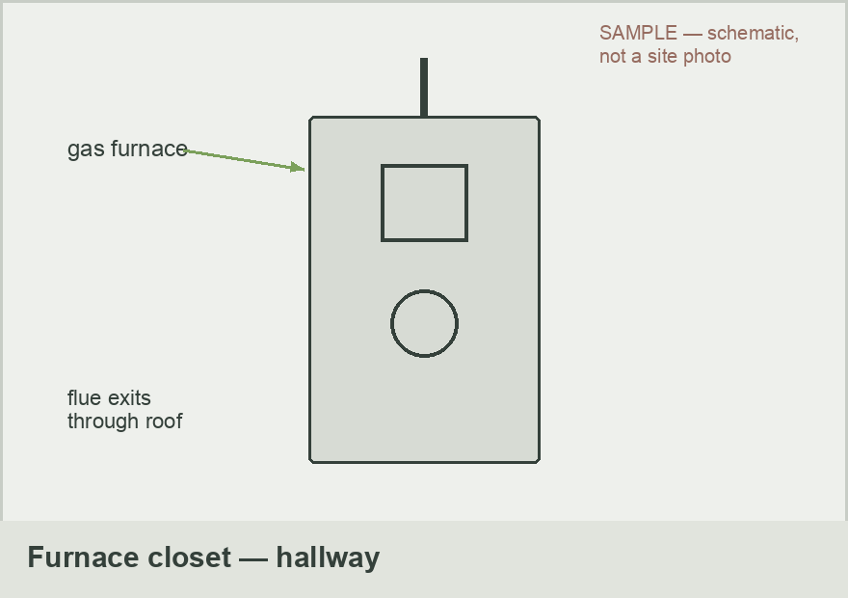 | 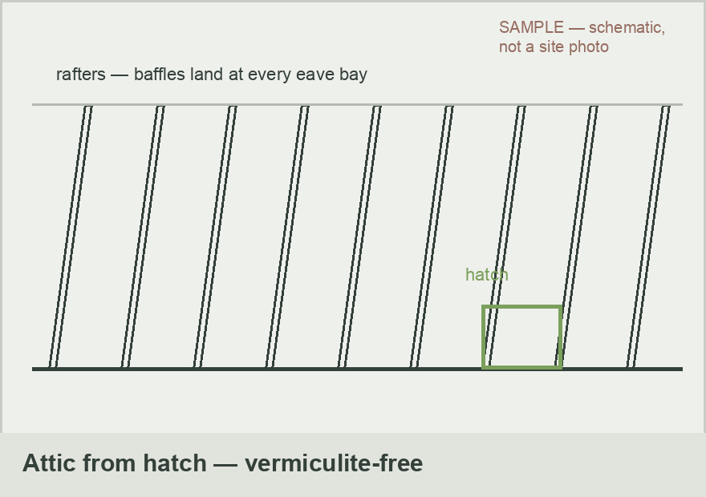
Furnace closet, hallway — gas capped at the appliance Day 1 | Attic from hatch — vacuum out, air-seal, baffles at every eave bay
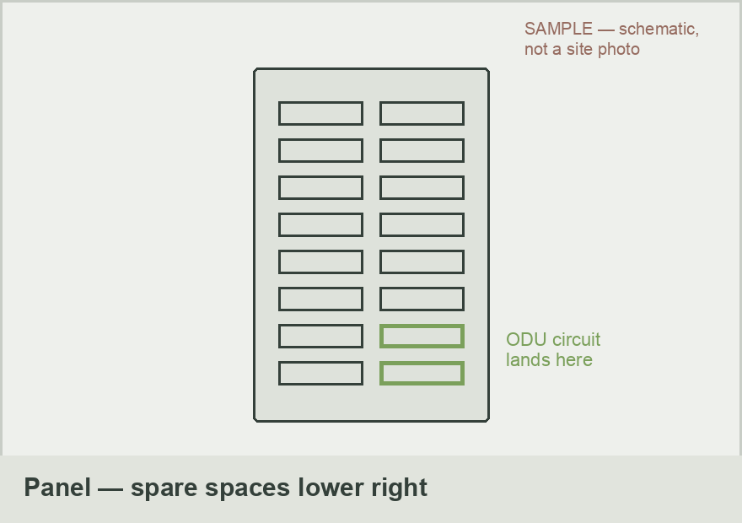 | 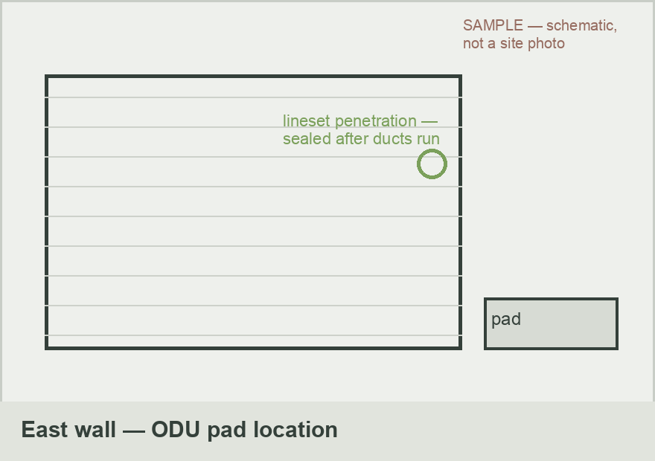
Panel in garage — ODU circuit lands in the spare spaces, lower right | East wall ODU location — pad here, lineset penetration sealed after ducts run
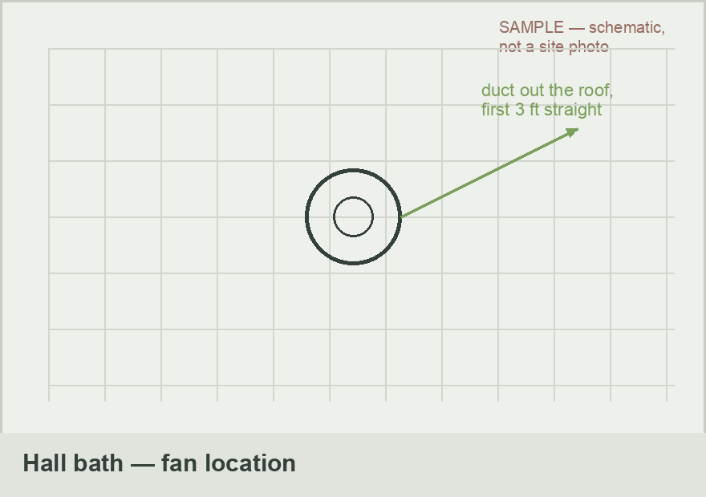 | 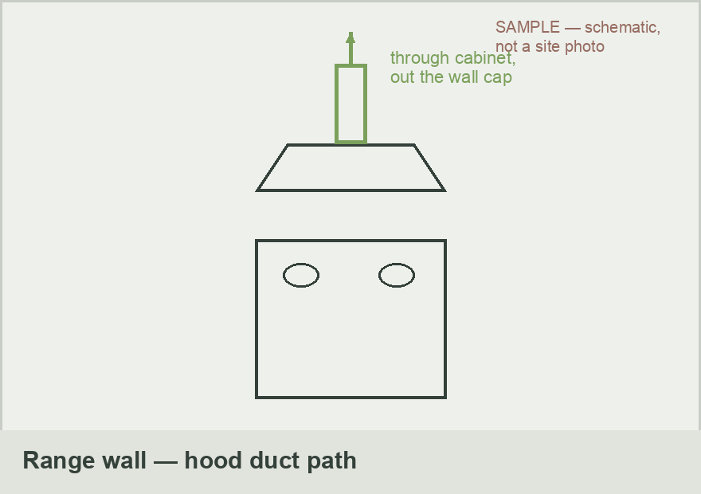
Hall bath fan location — duct out the roof, first 3 ft straight | Range wall — hood ducts through the upper cabinet, out the wall cap
Completion Sign-Off
Crew Lead | Signature: ______________________________ Date: ____________
Homeowner | Signature: ______________________________ Date: ____________
Final QC by | Name: ____________________ Blower door / results attached ☐

Resilient Retrofits · CCB# 245539 · Prepared by: Kyle Kanooth

